**Software Engineering  
Review-2**

**Peer-to-peer Book Rental Service**

**GROUP MEMBERS:**

Gaurav Kumar Singh (19BCE2119)

Piyush Rajput (19BCE0689)

Ayush Gupta (19BCE2422)

Aryan Singh (19BCE2295)

**Work Breakdown Structure**

**Deliverable-based WBS**

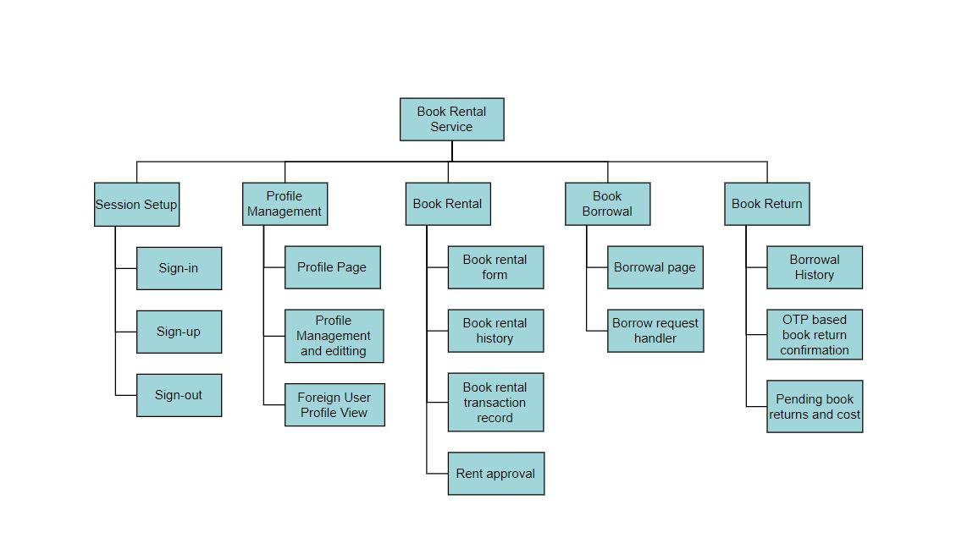

**Phase-based WBS**

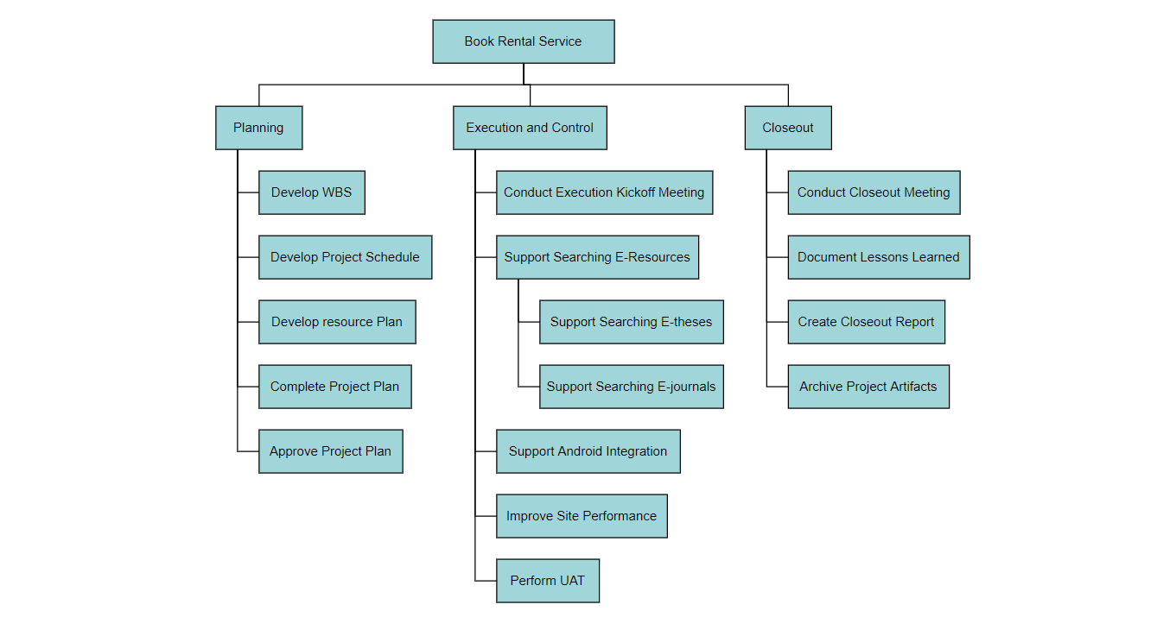

**Responsibility-based WBS**

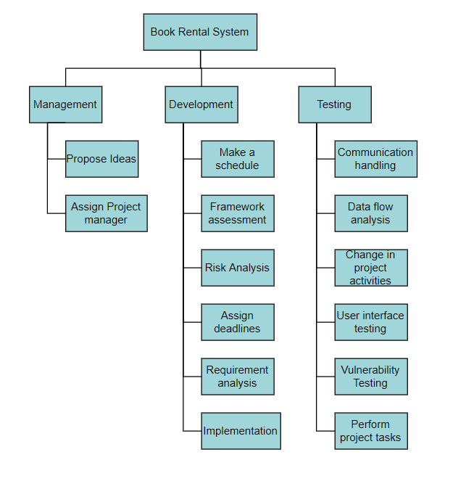

**Code**

Link:- <https://github.com/Gaurav1020/BookLook>

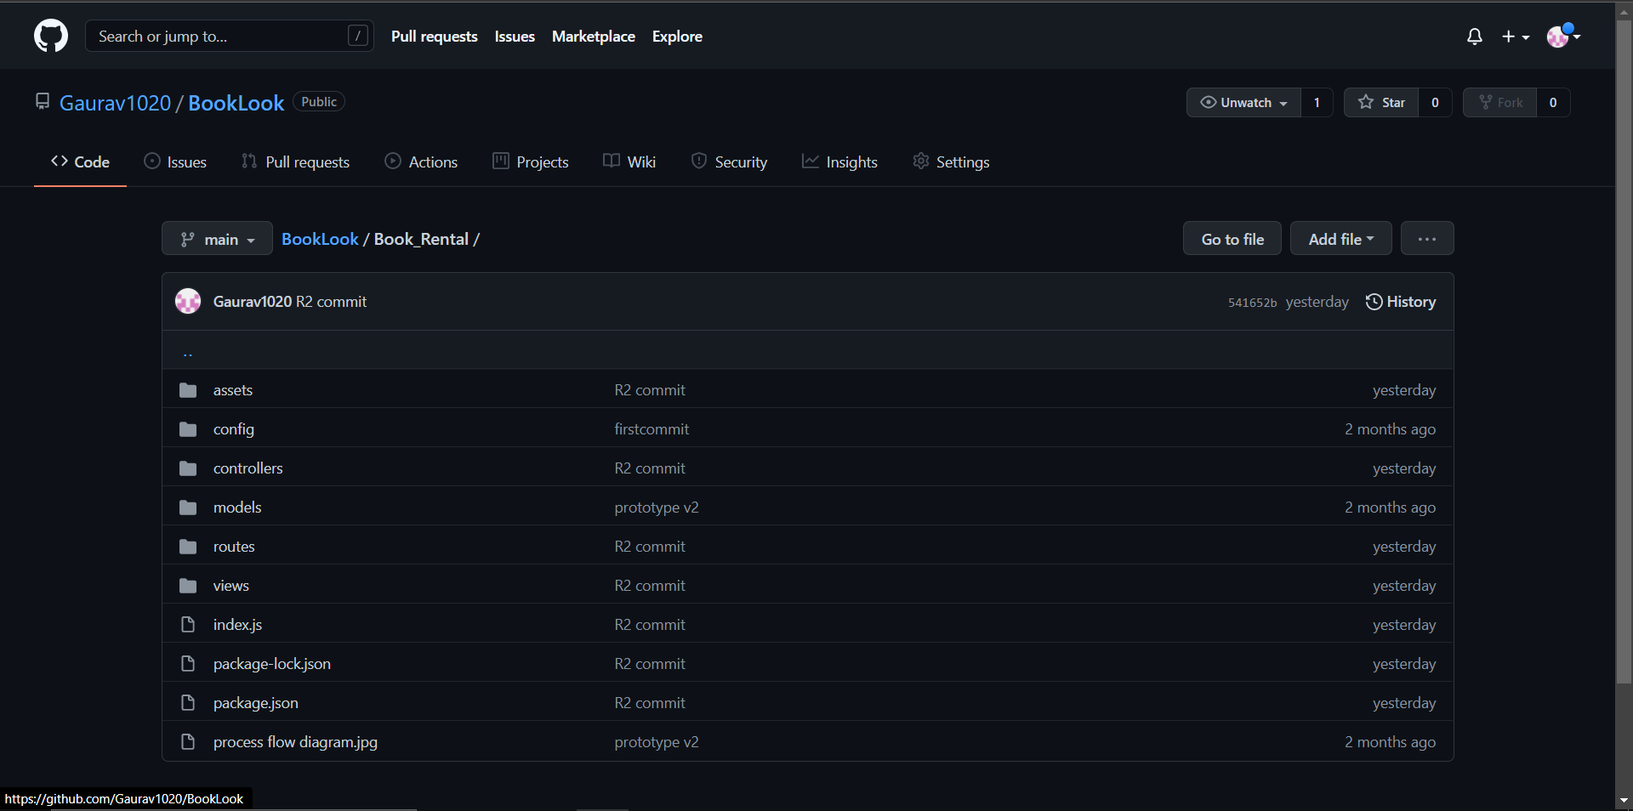

**Summary**

* Language used: HTML

CSS

JavaScript

* Framework used:  Nodejs

Expressjs

Passportjs

Bootstrap

Jquery

Mongoose

* Architecture used: MVC (Model, View, Controller)

* Database used: MongoDB (NoSQL)

* Process Model: Incremental Model

* Software used: Google Chrome

Visual Studio Code

Visual Paradigm Online

Robo3T/Compass

PROCESS FLOW DIAGRAM

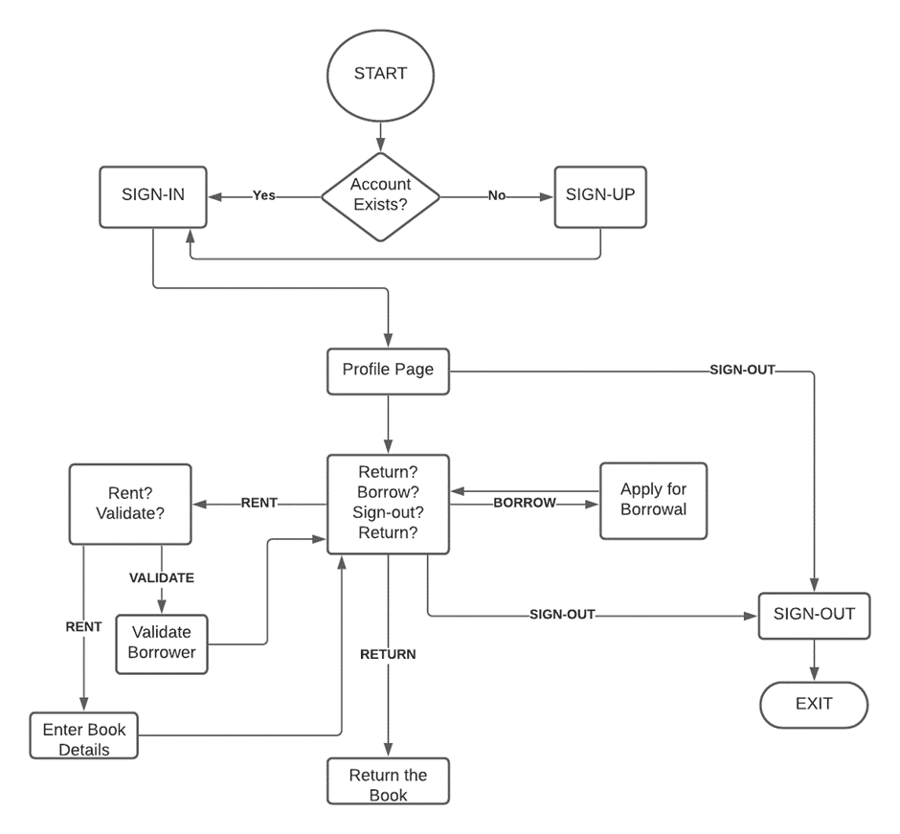

On the home page, the user has to login into their account. If they do not have an account then the user has to sign up to the portal. After signing up, the user is redirected to the sign-in page where the user credentials are verified. If the credentials are correct, the website creates a session cookie to keep the user signed in and prevents access to sign-in and sign-up pages to prevent malicious users from using their generated cookie to access other accounts. Also, a middleware is configured to check if the user is trying to bypass login to access restricted pages and if they are; the user is redirected to the login page to log in with their credentials and session cookie. After signing in, the user can see his/her profile. Users can update their profiles here. From here user gets an option to perform one of many activities. Users can choose to make a book available for rent, borrow books, return the borrowed books, or either sign out.

If the user chooses to check the rental system, he will be redirected to another page that is composed of two components, the book rental system, and the history of previously rented books. In the book rental system, there will be a form in which details of the book which the user wants to give away for rent will be submitted and the book will be made available in the borrow section of the application. The history section of the page is mainly used for two tasks. Firstly, to show details of all transactions. Secondly, if any other user sends a request to borrow the book, the renter gets to choose if he wants to lend the book to that particular user or not. The book transaction gets through the initiation state only after the borrower is validated by the renter.

On the borrower section, the user can send a borrow request to the vendor of the book and browse through all the books which are up for borrowing. The restriction is that the user cannot borrow the book which he made available to borrow.

On the book return section, users can see the list of all the books he/she had ever borrowed from the portal along with the option to return the books he currently has not returned to its owner. For the transaction to be safely finalized, we will be implementing an OTP-like system. Whenever a book is made available for rent, a random number is also generated as an OTP which only the renter has access to. For the borrower to be able to complete the transaction, he has to enter that OTP for confirmation which the vendor will tell him/her. If the OTPs don’t match, the transaction won’t close. If the OTPs match, it can be deduced that both the borrower and vendor approve the completion of a transaction and therefore can be terminated.

The user can also manually sign out which expires the session cookie, otherwise, the session cookie will automatically expire after some time, making the user log in again for security reasons.